Nama : Nurul Chotimah

NIM : 18090046

Kelas : 5A

**Praktikum 2**

1. Source Code

View-latihan1.php->application/views

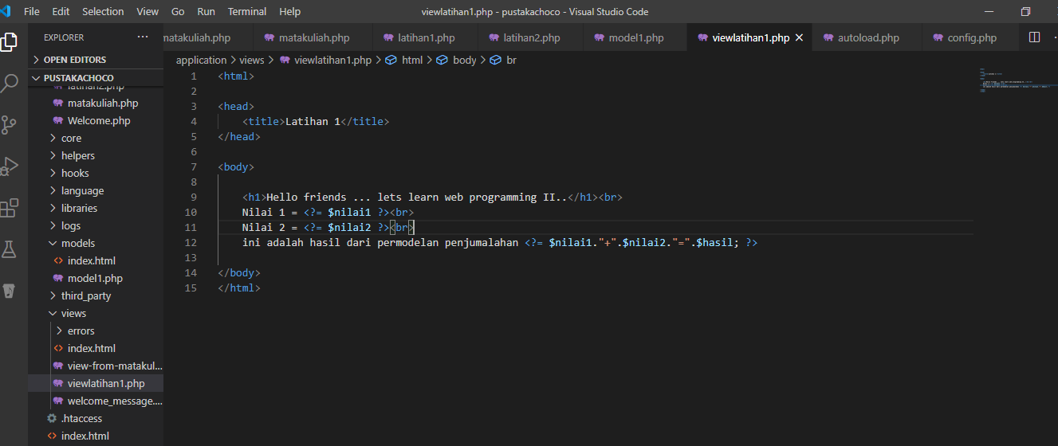

latihan1.php->application/controllers

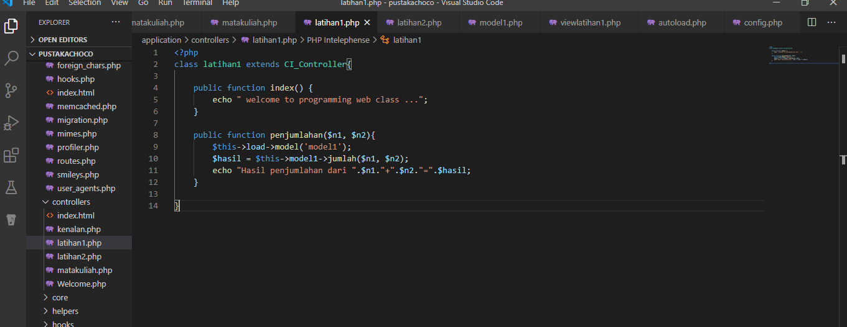

latihan2.php->application/controllers

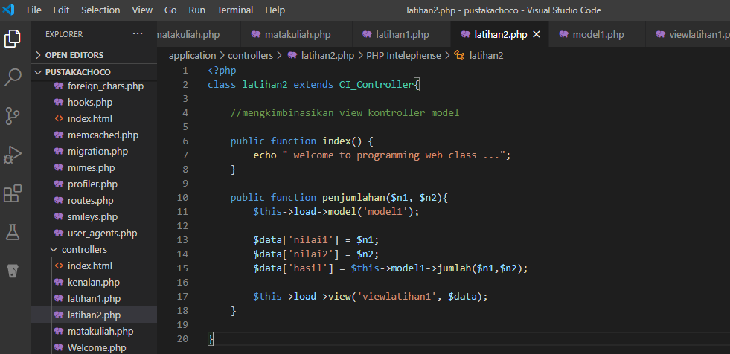

model.php->application/models

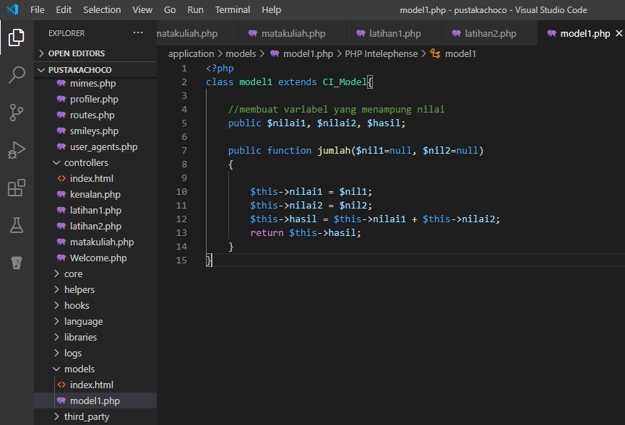

1. Hasil URL

<http://localhost/5/pustakachoco/index.php/latihan1>

<http://localhost/5/pustakachoco/index.php/latihan1/penjumlahan/4/5>

<http://localhost/5/pustakachoco/index.php/latihan2/penjumlahan/1/1>

1. Capture Hasil

